Installation and configuration of LAMP stack. Deploy an open-source

application such as phpmyadmin and Wordpress.

INSTALLING LAMP

Procedure:

Step 1: Update your system

sudo apt update

sudo apt upgrade

Step 2: Install Apache

sudo apt install apache2 -y

To check whether installed or not:

Open web browser and search localhost in address bar

then apache2 default page is displayed .Successfully installed.

Step 3: Firewall setting

sudo ufw status

if inactive the sudo ufw enable

sudo ufw app list

sudo ufw allow in “Apache Full”

clear

Step 4: Installing MySQL

sudo apt install mysql-server -y

or

sudo apt install mariadb-server mariadb-client

Check installation:

sudo systemctl status mysql

sudo mysql_secure_installation

sudo mysql

show databases;

create database name;

Step 5:Installing php

sudo apt install php -y

php version : php -v

cd /var/www/html

sudo gedit filename.php

Open web browser and search localhost/filename.php in address bar

Step 6:Install phpMyAdmin

sudo apt install php-mbstring php-zip php-gd php-curl php-json

sudo apt install phpmyadmin -y

Press space and enter

Set password

sudo systemctl restart apache2

Open browser and type localhost/phpmyadmin

Type username phpadmin and password

Step 7: Host WORDPRESS

1)Open browser and go to https://wordpress.org/latest.zip

2)Copy the link address and open terminal

3)Install wget (if not installed) -> sudo apt install wget

wget (paste the copied link address)

4)Install unzip (if not installed) -> sudo apt install unzip

5)Go to wordpress directory

cd wordpress/

6)Copy all the files in wordpress recursively

sudo cp –r * /var/www/html

cd /var/www/html

7)Remove one file name “index.html”

sudo rm –rf index.html

8)Change permission(ownership) of the files

sudo chmod –R www-data:www-data /var/www/

9)Open browser and type localhost

10)WordPress window will be opened -> successful installation

11)Select English Language and continue

12)Set database Connection details :

13)Open terminal

sudo mysql –u root –p

(Enter password of database)

⮚ create database [databasename];

⮚ create user “[username]” identified by “[password]”;

⮚ grant all privileges on [databasename].* to “[username]”;

⮚ exit

Database Name : [databasename]

Username : [username]

Password : [password]

Database Host : localhost

Table Prefix : wp_

OUTPUT

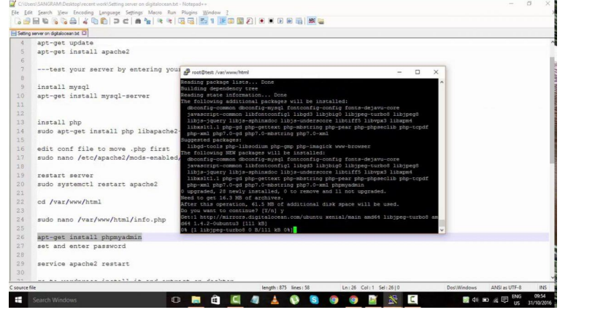

PHPMYADMIN

